DS 522 Data Acquisition and Analytics
HOS08A-2 Data Visualization with PBI
08/27/2024 Developed by Catherine Ata
10/01/2024 Reviewed by Yogesh Goel
05/20/2025 Reviewed by Naveena Moddu
04/23/2026 Reviewed by Vishal Krishna Kumar
School of Technology & Computing (STC) @ City University of Seattle (CityU)

Before You Start
- Version numbers may not match the most current version at the time of writing. If given the option to choose between the stable release (long-term support) or the most recent, please select the stable release rather than the beta-testing version.
- This tutorial targets Windows users and MacOS users.
- There might be subtle discrepancies along with the steps. Please use your best judgment while going through this cookbook-style tutorial to complete each step.
- For your working directory, use your course number. This tutorial may use a different course number as an example.
- The directory path shown in the screenshots may be different from yours.
- If you are not sure what to do or confused with any steps:
- Consult the resources listed below.
- If you cannot solve the problem after a few tries, ask a TA for help.
Key Concepts
- Power BI (Business Intelligence) Power BI is a powerful Data Visualization and Business Analytics tool provided by Microsoft. It helps us to provide interactive visualizations, dashboards, and Bi Reports with self-service capabilities. It is part of Microsoft Power Platform.
- Power BI Desktop is a free application you install on your local computer that lets you connect to, transform, and visualize your data. With a Power BI Desktop, you can connect to multiple various sources of data and combine them (often called modeling) into a data model. This data model lets you build visuals, and collections of visuals you can share as reports, with other people inside your organization. Most users who work on business intelligence projects use Power BI Desktop to create reports and then use the Power BI service to share their reports with others.

Learning Outcomes
- Creating standard visuals
References
- Microsoft. (2023). Table in Power BI reports and dashboards. https://docs.microsoft.com/en-us/power-bi/visuals/power-bi-visualization-tables
- Power BI Docs. (2024). What is Power BI? Power BI Docs. https://powerbidocs.com/2019/11/28/what-is-power-bi/
- Power BI Docs. (2024). What is Power BI Desktop? Power BI Docs. https://learn.microsoft.com/en-us/power-bi/fundamentals/desktop-what-is-desktop

Creating Basic Plots
Open your Power BI Desktop App, navigate to and then open the HOS08.pbix file provided with this assignment.
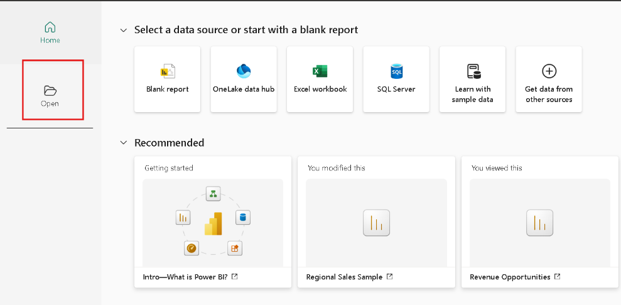
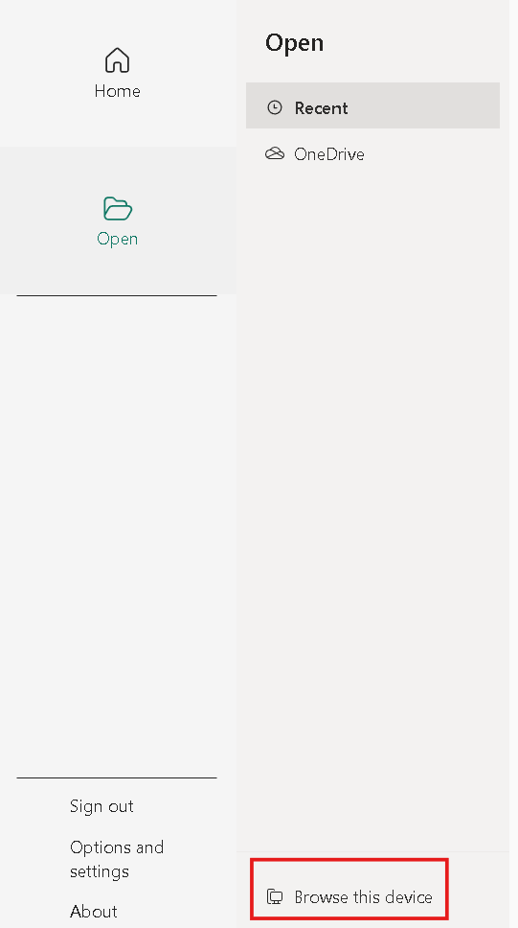
In the previous exercises, we performed data acquisition, preparation, and transformation. Now let us learn about front-end visualization creation.
Go to the Report View, and under the Build pane on the right side of the app, select the ‘Table’ object.
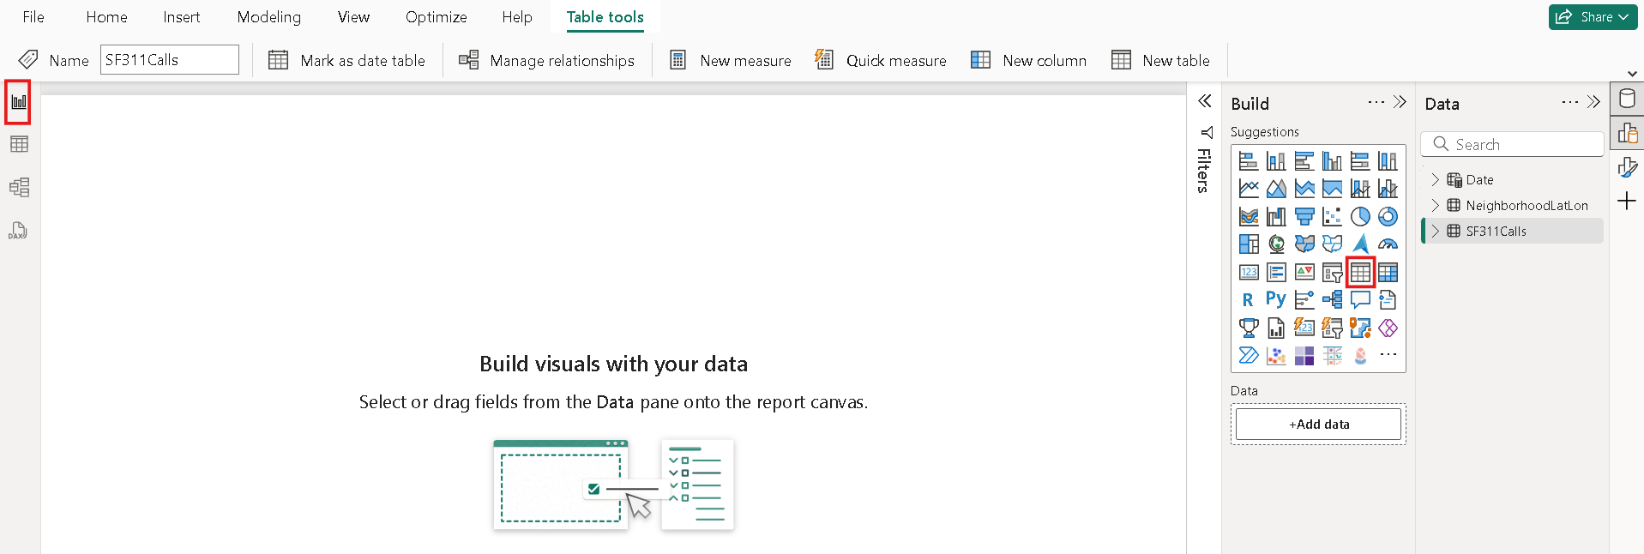
It will open an empty table on the main report page.
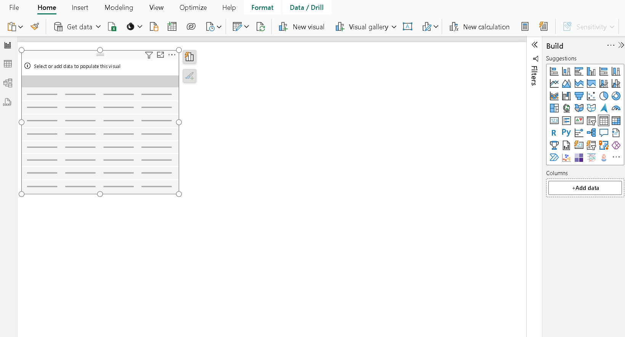

Click on Add data
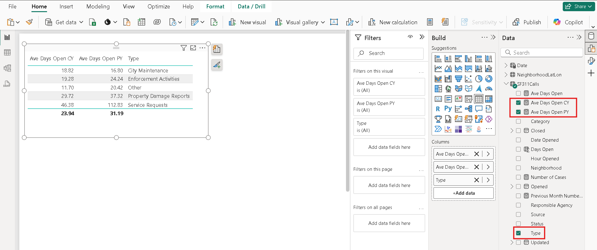
Now, let us select the fields we want to add to this object. You can do that by simply selecting the fields you want from each table, as shown in the figure below, and they will be added automatically to your table object. Please take a screenshot and put it in your submission document.
We can also add the required filters to the report, which gives the user options to select the data they want to see on the information.
Make sure your table object is selected and drag the ‘Status’ data into the ‘Add data field here’ under the ‘Filters on this visual' section found under the Filters pane, as shown below.
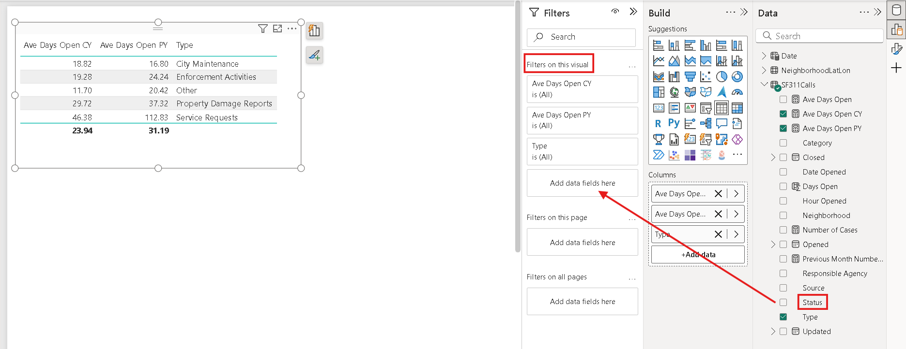
As you can see, this is currently filtering data using the ‘Type’ data field, once you have successfully dragged and drop the ‘Status’ data field, this will changed to ‘Status’ and this will open the Filter type.
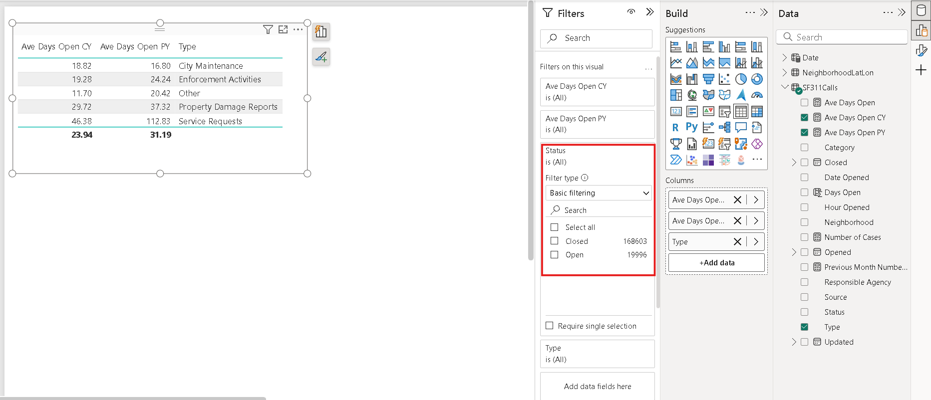
Take note of the values in your table on the main page.
Let us select the ‘Closed’ option which will filter that data for the closed days. Now do you notice the changes in the values?
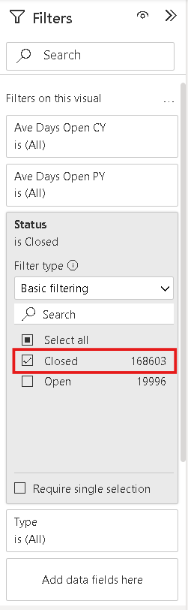
Please take a screenshot that includes the table and the Filters pane.
Let us add another object to this report under the Build pane again. Click on the empty area next to the table object, and under the Build pane, select the '100% stacked bar chart' as shown below.
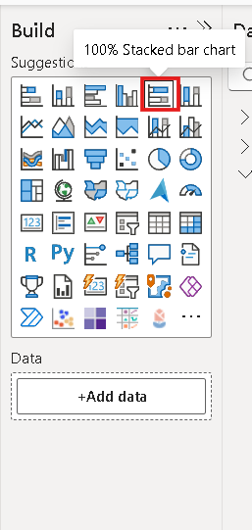
Let us then add data fields to this object. You can do this by dragging the data fields to the corresponding Build section as shown below.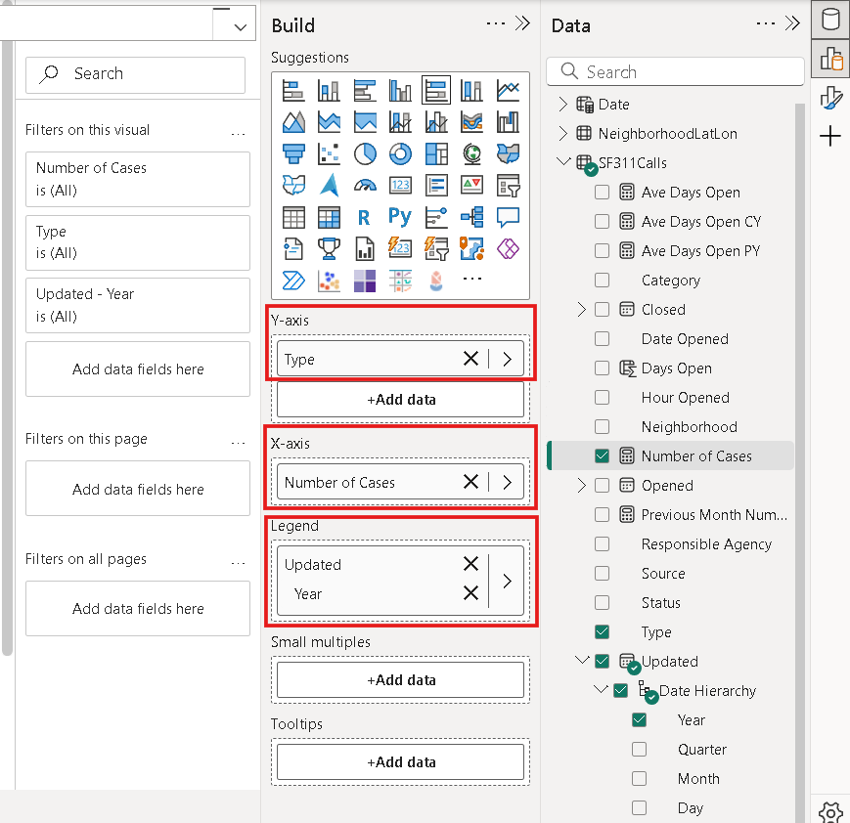
Your report will look like this at this point.
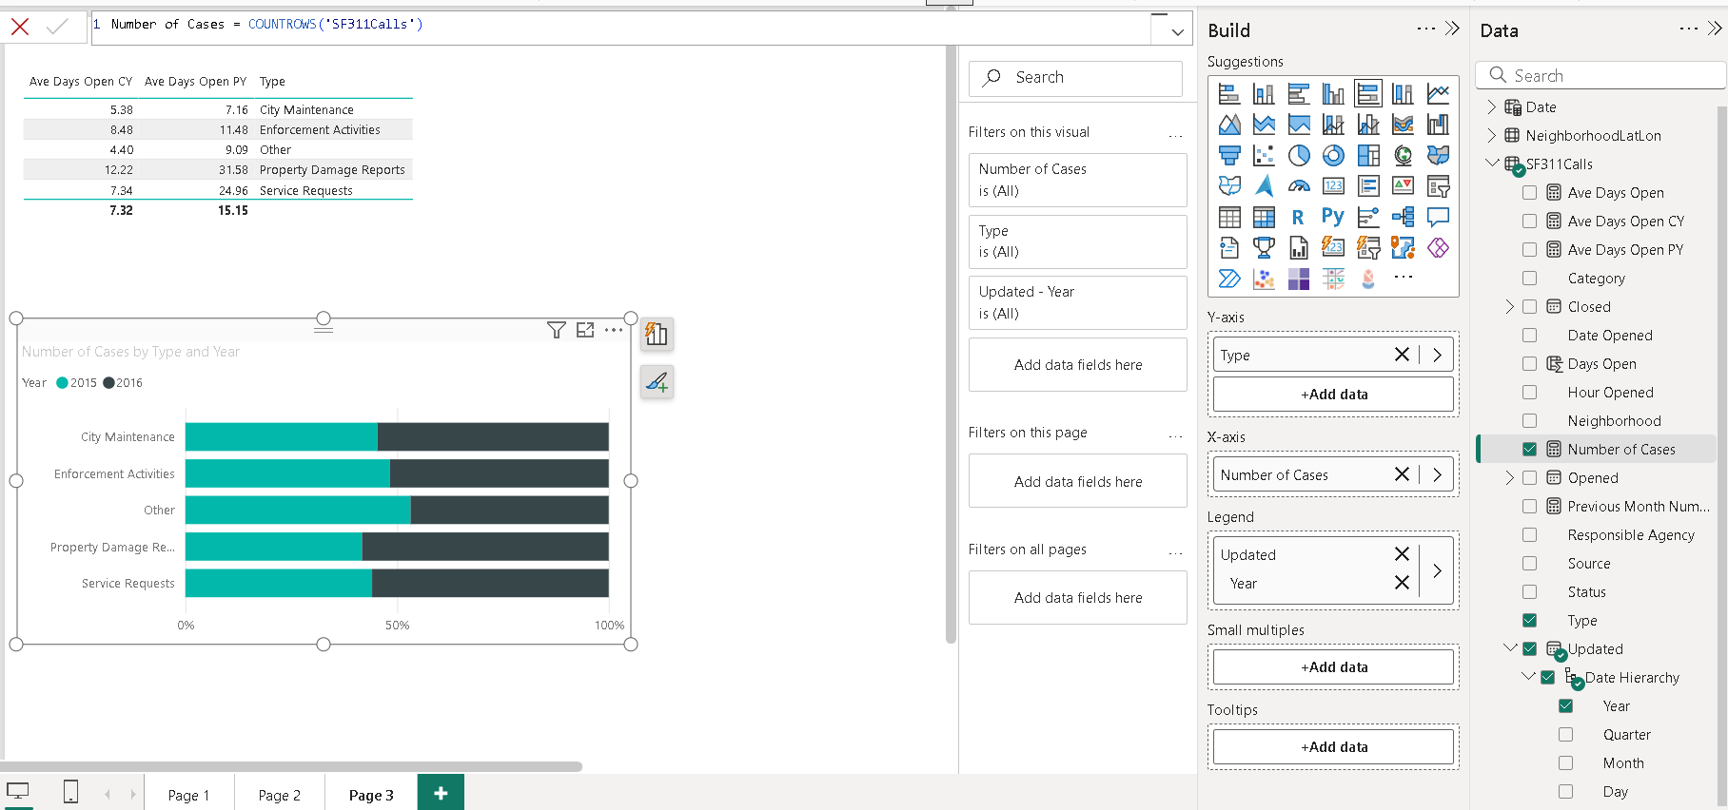
Please take a screenshot of the Report View now.
Let us create another report and add visualizations. We can do that by clicking the + sign shown below.
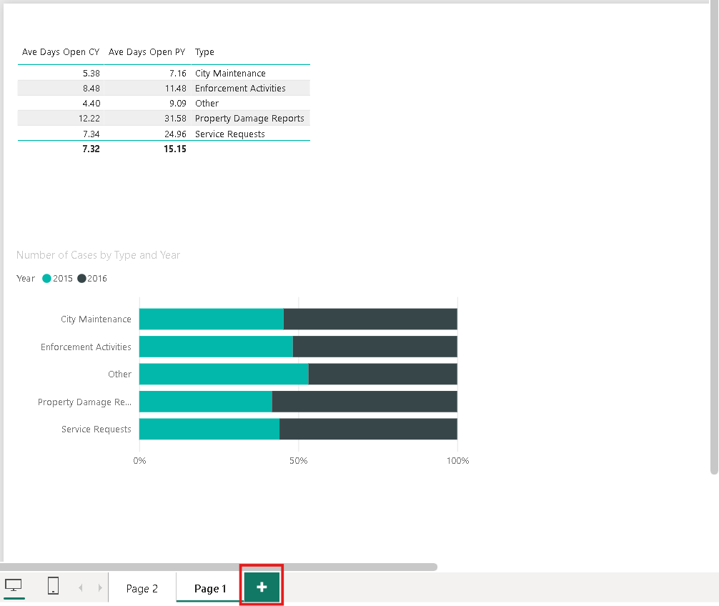
This time, let us build a Line Chart on this new page.
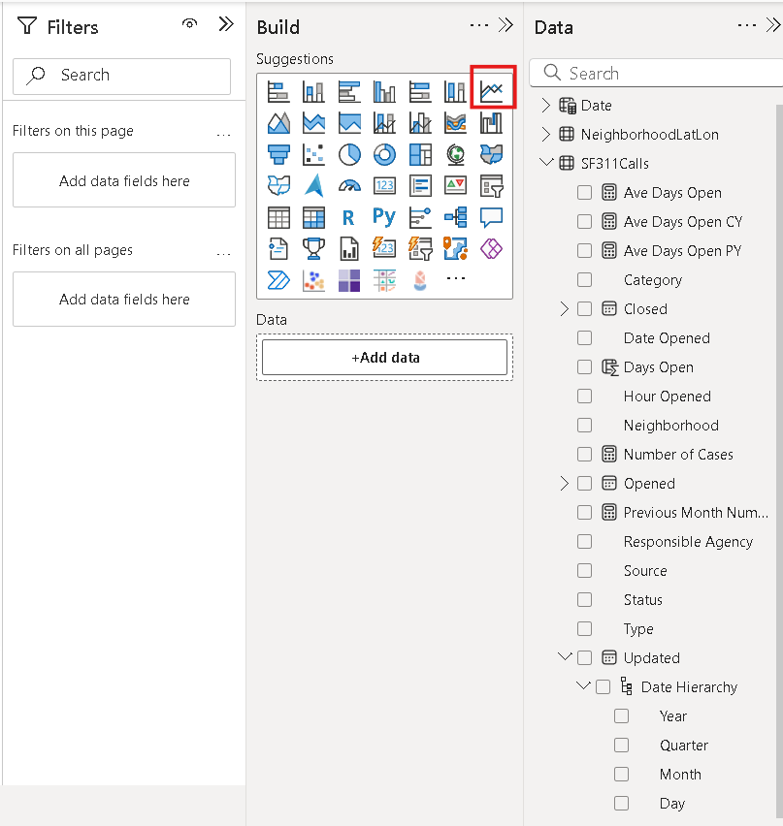
Add the Number of Cases data field and Week Ending Date to Y-axis and X-axis, respectively and as shown below.
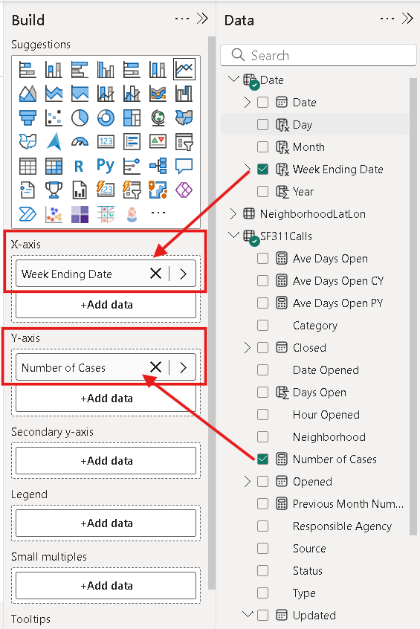
Make sure to select the Week Ending Date from the drop-down menu below.
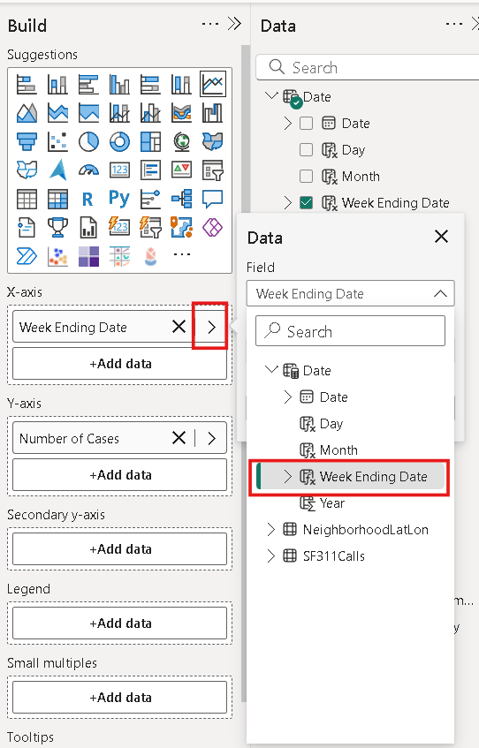
On the right tab of the app, select ‘Format’ to open the ‘Format’ pane.
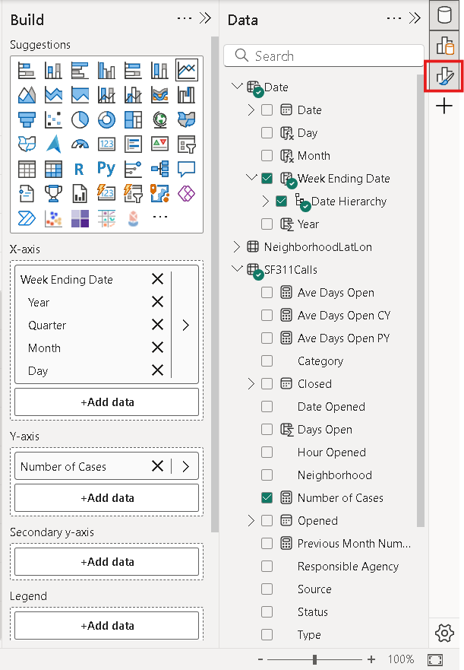
Once the ‘Format’ pane is accessible, make sure the Trend Line is On.
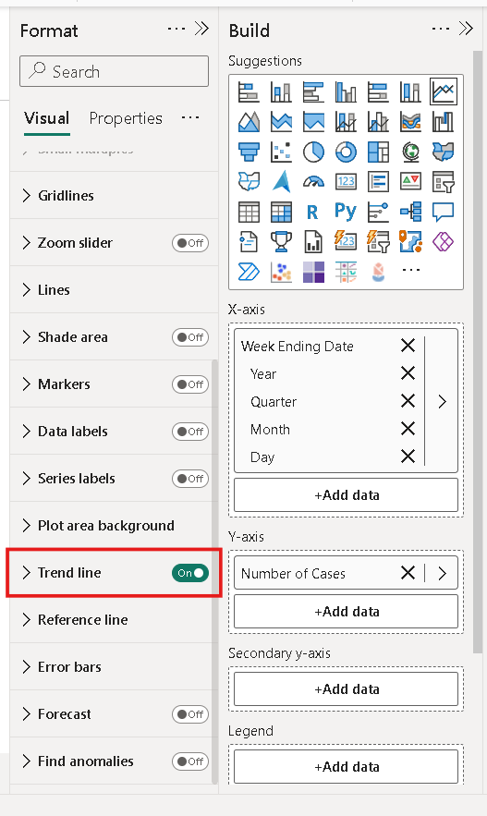
Click on the drop-down menu to show the different options. Make sure each property is set as such:
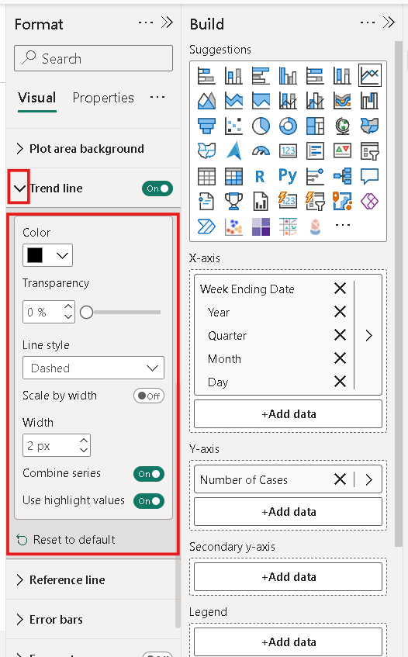
Make sure you deselected the Line Chart object. Let us then add a Date slicer object that lets us select a date range for which we want to see the data.
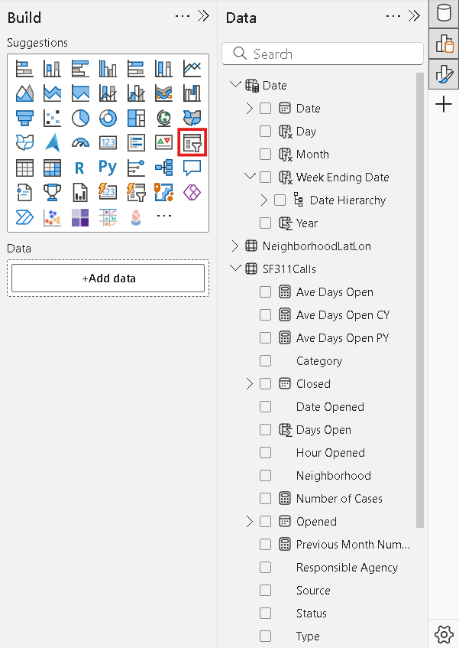
Add the Week Ending Date to the slicer by drag and drop method.
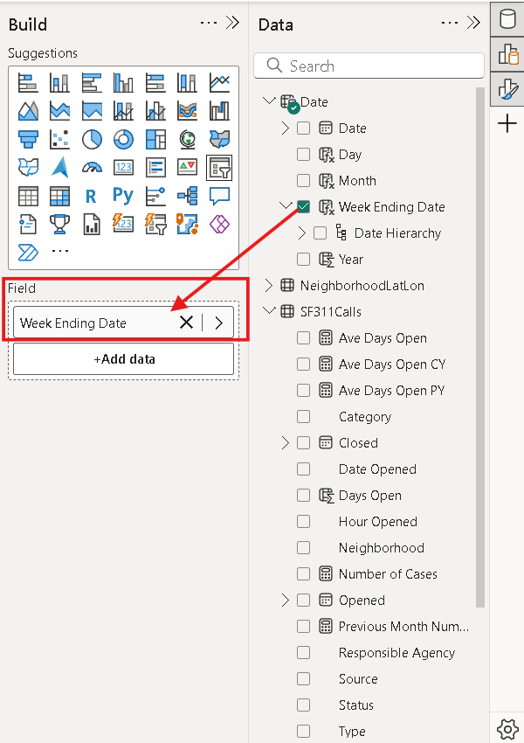
You can move the slicer up and down to get the desired date range. You can also rearrange the objects on the page to get a user-friendly view by simply dragging and dropping them around.
Your final report should look something like this.
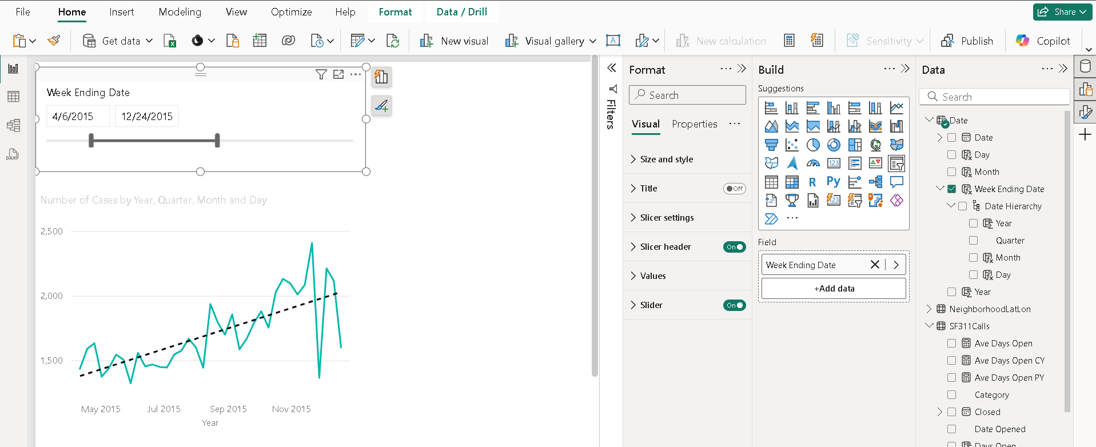
Please take a screenshot of this page.

Push your work to GitHub.

Include your screenshots stored in this file: HOS08A-2 – Name_Submission.pdf

Follow the instructions on the CityU STC TA Center Github.io. Submit your work page.

